Below is (1) a full implementation guide for your current PoC, and (2) an MCP context diagram you can turn into PNG.

1. Full implementation & update guide for your PoC

1.1 Project structure
Your final project structure should look like:
text
agentic-banking-poc/
│
├─ app.py # Streamlit RM Assistant UI
├─ data_tools.py # Tool layer (logic, masking, logging)
├─ setup_db.py # Creates mock core DB
├─ banking_core.db # SQLite mock core (generated)
├─ mcp_server.py # MCP server (AgenticBankingGateway)
├─ tool_client_test.py # Headless tool test (no UI)
├─ requirements.txt # Python dependencies
├─ README.md # Project + MCP description
├─ .gitignore # Ignore logs, venv, etc.
└─ .venv/ # (local) virtual environment

1.2 One-time setup

1.2.1 Create folder and venv
bash
mkdir agentic-banking-poc
cd agentic-banking-poc
python -m venv .venv

# Activate venv
# Windows:
.\.venv\Scripts\activate
# Mac/Linux:
# source .venv/bin/activate

1.2.2 Install dependencies
requirements.txt:
text
streamlit
mcp
Install:
bash
pip install --upgrade pip
pip install -r requirements.txt
The mcp package is the official MCP Python SDK.pypi+1

1.3 Data layer – mock core banking DB
File: setup_db.py
(You already have this; keep as is.)
Key steps:
- Creates banking_core.db.
- Table: accounts(account_id, customer_name, balance, account_type, kyc_status).
- Seeds sample accounts across Savings / Current / Gold, with varied balances & KYC.
Run once (or whenever you want fresh data):
bash
python setup_db.py
Expected: “Mock Banking Core Ready at …” and a banking_core.db file.

1.4 Tool layer – data_tools.py
This file provides:
- Low-level DB connection.
- Masking function.
- Text tools (get_account_details, identify_high_value_customers).
- Structured tools for agents/MCP (get_account_details_structured, identify_high_value_customers_structured).
- Logging to poc.log.
Key elements (summary)
At the top:
python
import sqlite3
import hashlib
import logging
from pathlib import Path
from typing import Dict, List

DB_FILE = "banking_core.db"

logger = logging.getLogger("agentic_poc")
logger.setLevel(logging.INFO)
if not logger.handlers:
file_handler = logging.FileHandler("poc.log")
formatter = logging.Formatter(
"%(asctime)s | %(levelname)s | %(name)s | %(message)s"
)
file_handler.setFormatter(formatter)
logger.addHandler(file_handler)
Connection + masking:
python
def _get_connection():
db_path = Path(DB_FILE)
if not db_path.exists():
logger.error("Database file not found at %s", db_path.absolute())
return sqlite3.connect(db_path)

def mask_name(name: str) -> str:
token = hashlib.md5(name.encode()).hexdigest()[:4]
return f"CUST_{token}"
Text tool (for CLI/UI history):
python
def get_account_details(account_id: str) -> str:
...
Structured tools (for MCP/agents):
python
def get_account_details_structured(account_id: str) -> Dict[str, object]:
...
return {
"account_id": acc_id,
"customer_name": name,
"balance": balance,
"account_type": acc_type,
"kyc_status": kyc,
}

def identify_high_value_customers_structured(
threshold: float = 50000.0,
) -> List[Dict[str, object]]:
...
return [{"masked_id": mask_name(name), "balance": balance} for name, balance in rows]
All functions log TOOL_CALL and TOOL_RESULT lines to poc.log.

1.5 Headless test – tool_client_test.py
Use this to test tools without UI:
bash
python tool_client_test.py
You already validated output:
- Single account dict.
- List of masked high-value customers (12 entries).
Use this script whenever you change the data model or tool logic to ensure they still work.

1.6 Streamlit UI – app.py
Core responsibilities:
- Provide RM chat interface.
- Route queries to either account-details tool, high-value tool, or help.
- Render structured UI (metrics, table).
- Log queries and responses.
Implementation (you have this now):
- Uses st.chat_input and st.chat_message.
- “High value” route: table of Customer Token + formatted balance.
- “ACCxxx” route: header + 3 metrics + info card.
- Everything else: help message.
Run locally:
bash
streamlit run app.py
Test flows:
- Show high value customers → table with CUST_xxxx tokens.
- Get details for ACC003 → account overview.
- Get details for ACC999 → error message.

1.7 MCP server – mcp_server.py
This wraps structured tools with MCP using the official SDK.modelcontextprotocol.github+1
Key parts:
python
from typing import Dict, List
from mcp.server.fastmcp import FastMCP
from data_tools import (
get_account_details_structured,
identify_high_value_customers_structured,
)

mcp = FastMCP("AgenticBankingGateway")

@mcp.tool(...)
def mcp_get_account_details(account_id: str) -> Dict[str, object]:
details = get_account_details_structured(account_id)
if not details:
return {"status": "NOT_FOUND", "account_id": account_id}
return {"status": "FOUND", **details}

@mcp.tool(...)
def mcp_list_high_value_customers(threshold: float = 50000.0) -> Dict[str, object]:
customers = identify_high_value_customers_structured(threshold)
return {"threshold": threshold, "count": len(customers), "customers": customers}

def main() -> None:
mcp.run()

if __name__ == "__main__":
main()
Run:
bash
python mcp_server.py
It will sit waiting for MCP JSON-RPC messages. Any stray input (like pressing keys in the console) can cause “Invalid JSON” warnings; those are expected if no proper client is attached.github+1
For v1, you mainly use this to demonstrate you know how to expose tools over MCP.

1.8 Git + GitHub + deployment workflow

1.8.1 Git basics (once)
Inside project folder:
bash
git init
git config --global user.name "Your Name"
git config --global user.email "your_email@example.com"

1.8.2 Files to track
bash
git add app.py data_tools.py setup_db.py banking_core.db mcp_server.py tool_client_test.py requirements.txt README.md .gitignore
git commit -m "Initial commit: Agentic Banking PoC"

1.8.3 Remote repo
- Create repo SMV1969/agentic-banking-poc on GitHub.
- Add remote & push:
bash
git remote add origin https://github.com/SMV1969/agentic-banking-poc.git
git branch -M main
git push -u origin main

1.9 Updating code and redeploying (very important for future changes)
Whenever you change code (e.g., new tool, new UI element):
- Run local tests:
  - python tool_client_test.py
  - streamlit run app.py (quick manual test)
- If good, commit:
bash
git status
git add <changed files>
git commit -m "Short description of change"
- Push:
bash
git push
- Streamlit Cloud auto-rebuild:
- Go to your app URL (e.g., https://agentic-banking-poc-…streamlit.app).
- Wait ~30–60 seconds; refresh.
- New version is live.
This is the cycle you’ll use every time you modify or extend your PoC.

2. MCP context diagram for this PoC
Here is a conceptual diagram of your architecture using MCP. I’ll give you a Mermaid version so you can:
- Paste it into tools that render Mermaid (VS Code, Obsidian, Mermaid Live Editor) to generate PNG/SVG.
- Or use it as a reference to redraw in draw.io / PowerPoint.

2.1 Mermaid context diagram
text
“ flowchart LR
subgraph UserLayer[User Layer]
RM[Relationship Manager<br/>Streamlit UI (app.py)]
Agent[Future AI Agent<br/>(MCP Client)]
end

subgraph MCPLayer[MCP Integration Layer]
MCPServer[AgenticBankingGateway<br/>(mcp_server.py)]
end

subgraph ToolLayer[Tool Layer]
Tools[data_tools.py<br/>Structured Tools<br/>- GetAccountDetails<br/>- ListHighValueCustomers<br/>+ Masking & Logging]
end

subgraph DataLayer[Data Layer]
DB[(banking_core.db<br/>Mock Core Banking DB)]
end

RM -->|HTTP/WebSocket| RMAPI[Streamlit Runtime]
RMAPI -->|Function calls| Tools

Agent -->|MCP (JSON-RPC)| MCPServer -->|Calls| Tools

Tools -->|SQL| DB
“
Interpretation:
- UserLayer:
  - RM uses the Streamlit UI today.
  - In future, an AI Agent (MCP client) can connect directly to AgenticBankingGateway.
- MCPLayer:
  - MCPServer wraps tools with MCP, accepting JSON-RPC messages over stdio or sockets as described in MCP SDK docs.modelcontextprotocol.github+1
- ToolLayer:
  - data_tools.py encapsulates business logic, PII masking, and logging.
  - Both UI and MCP server call this layer.
- DataLayer:
  - SQLite DB mimics core banking; later this becomes T24/Finacle/Oracle/etc.
To turn this into PNG:
- Go to any Mermaid live editor (e.g., mermaid.live).
- Paste the code.
- Export as PNG/SVG.
You can then include that PNG in your slides, README, or design docs.
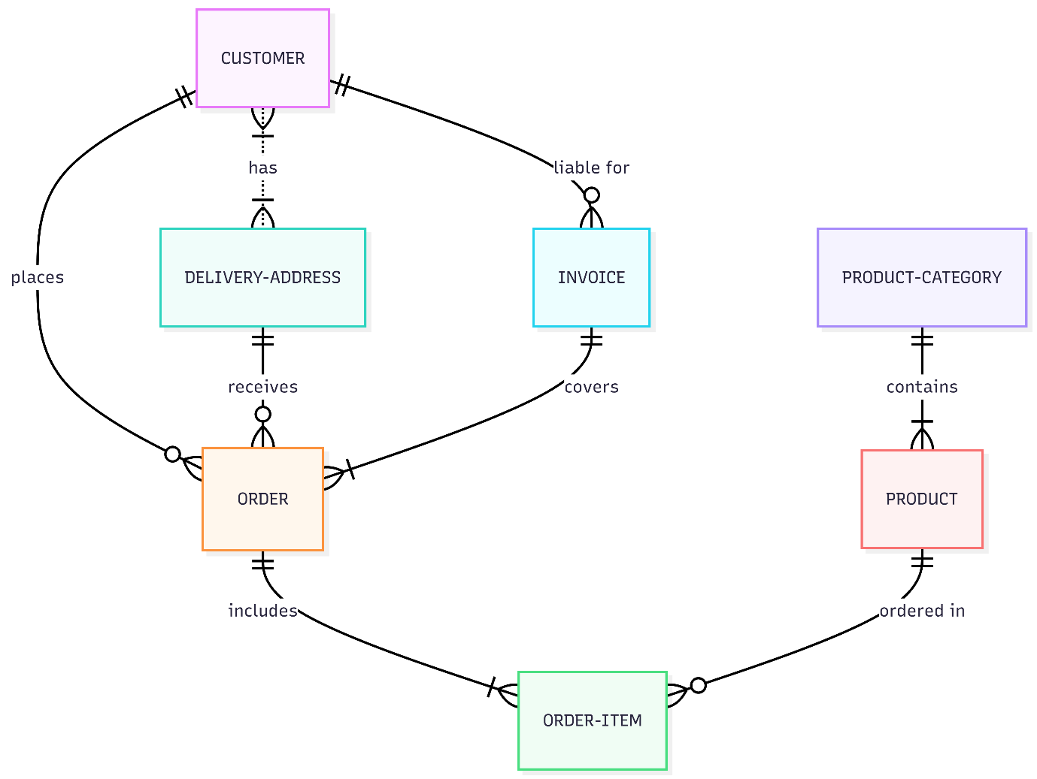

In the next document (your requested (3)), I’ll:
- Explain MCP in a banking context from first principles.
- Walk through several realistic BFSI use cases (RM copilot, fraud triage, KYC assistant, reconciliation).
- For each, describe how MCP tools, servers, and agents interact, with textual flow diagrams you can later convert to PNG.

